

**CS7081Enterprise Software Components and Systems Development**

**Coursework Assessment (2017-18)**

**Name: Khalid Ahmed Mohamed**

**ID: 13036087**

Table of Contents

1. Software Architecture 3

1.1 UML Deployment Diagram 3

2. Database Design 4

2.1 SQL DDL Script 5

3. Website Design 6

3.1 Page Navigation Map 6

4. Program Description 7

4.1 Use Case Model 7

4.1.1 High Level Use Case 7

4.1.2 Expanded Use Case 7

4.2 Entity Relationship Diagram 7

4.3 Sequence Diagram 7

4.4 Analysis Class Diagram 7

5. Screen Dump Walkthrough 8

6. Deployment 9

6.1 Component Diagram 9

6.2 Deployment and Configuration Instructions 9

# Software Architecture

## 1.1 UML Deployment Diagram

Software Architecture is foundation or fundamental design of the software. One of the main reason why the Software Architecture is important is because without it, it could be difficult to maintain or change once built due to a lack of knowledge.

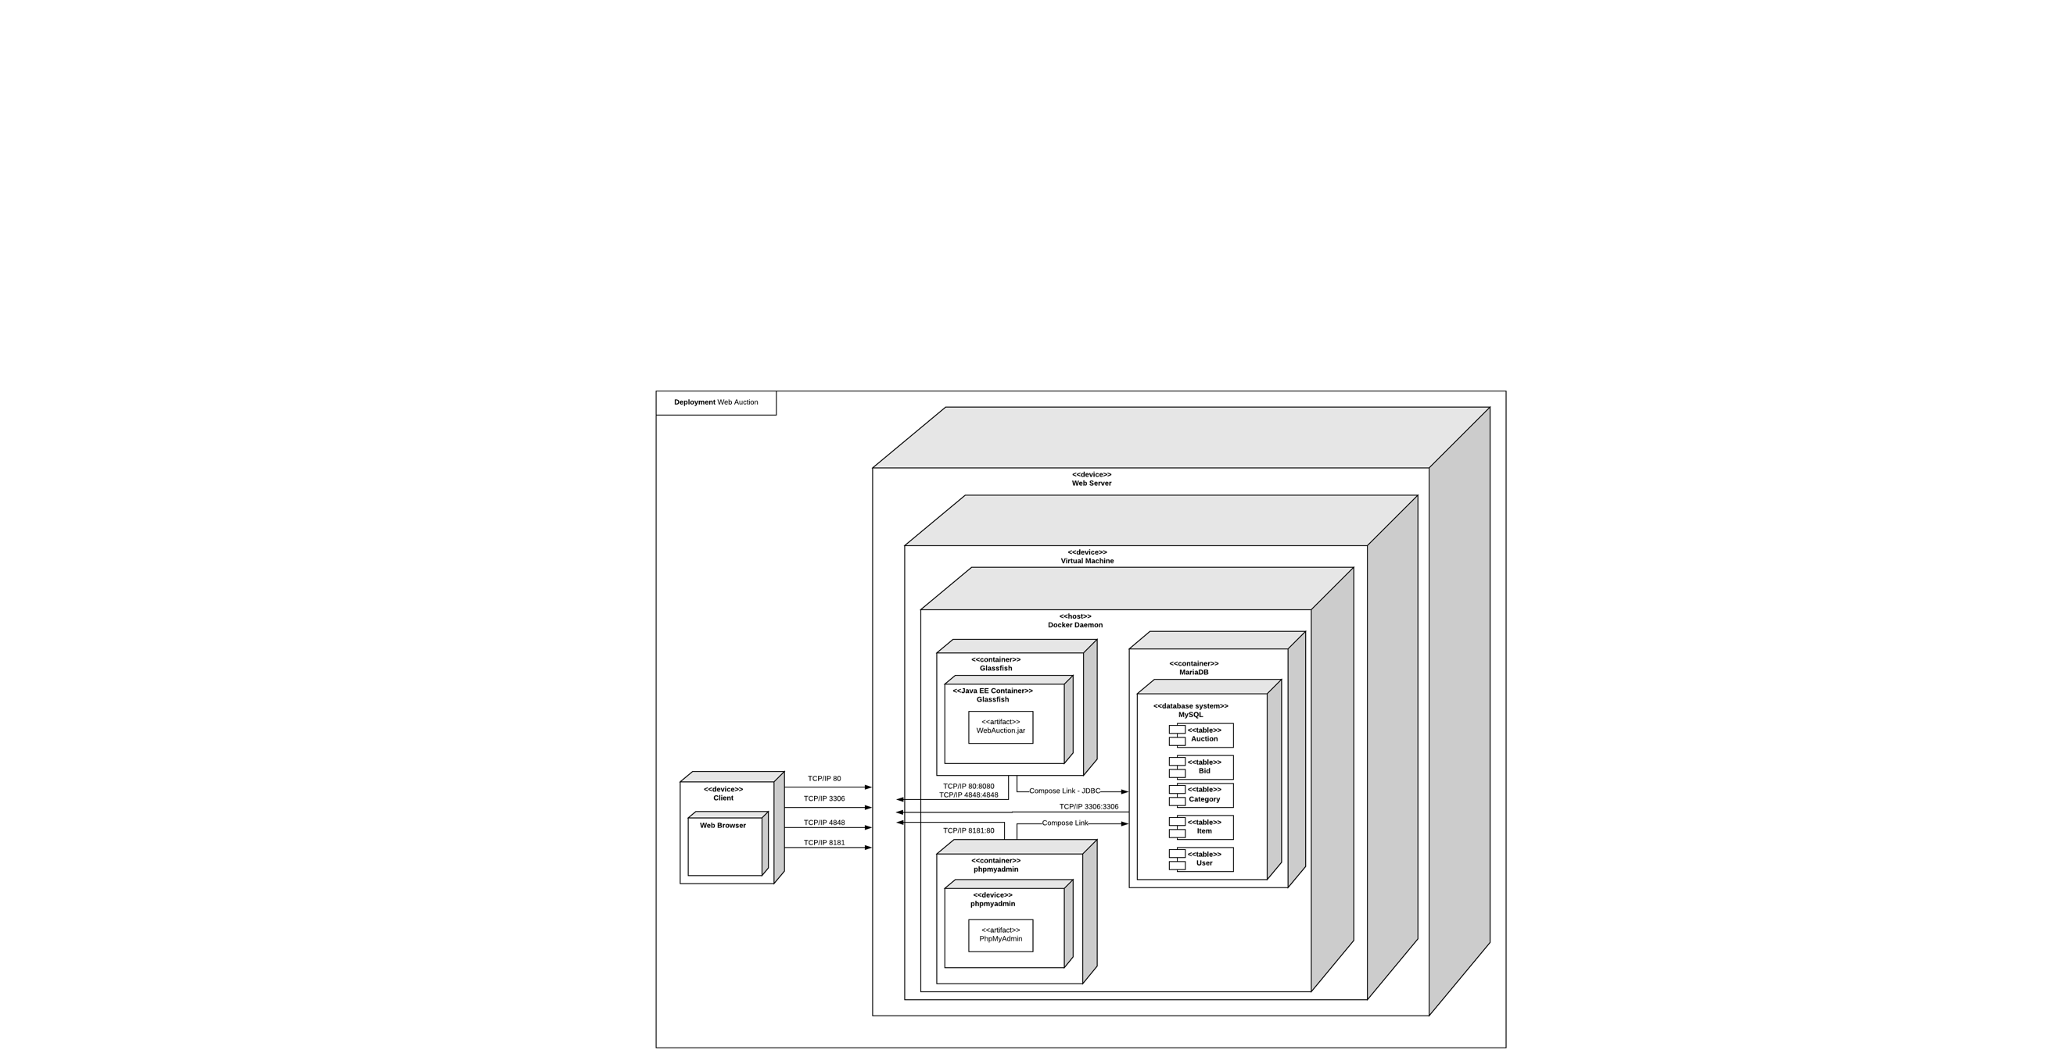

# Database Design

Database Design is the process of creating the structure of the database, identifying the tables, column, input types and the relationship between the tables.

|  |  |  |
| --- | --- | --- |
| Item | | |
| Index | **Name** | **Type** |
| PK | itemid | int(11) |
|  | itemname | varchar(50) |
| FK | catid | int(11) |
| FK | sellerid | int(11) |

|  |  |  |
| --- | --- | --- |
| Category | | |
| Index | **Name** | **Type** |
| PK | catid | int(11) |
|  | catName | varchar(50) |

|  |  |  |
| --- | --- | --- |
| Auction | | |
| Index | **Name** | **Type** |
| PK | auctionId | int(11) |
| FK | itemId | int(11) |
|  | startPrice | double |
|  | currentBid | double |

|  |  |  |
| --- | --- | --- |
| User | | |
| Index | **Name** | **Type** |
| PK | userid | int(11) |
|  | name | varchar(50) |
|  | username | varchar(50) |
|  | password | varchar(50) |
|  |  |  |

|  |  |  |
| --- | --- | --- |
| Bid | | |
| Index | **Name** | **Type** |
| PK | bidid | int(11) |
| FK | auctionId | int(11) |
| FK | bidderId | int(11) |
|  | bidAmount | double |
|  | time | varchar(100) |

## 2.1 SQL DDL Script

CREATE TABLE User

(userid int (11) NOT NULL AUTO_INCREMENT,

name VARCHAR (50) NOT NULL,

username VARCHAR (20) NOT NULL,

password VARCHAR (20) NOT NULL,

CONSTRAINT PK_ User PRIMARY KEY (userid));

CREATE TABLE Category

(catid int (11) NOT NULL AUTO_INCREMENT,

catName VARCHAR (50) NOT NULL,

CONSTRAINT PK_ Category PRIMARY KEY (catid));

CREATE TABLE Item

(itemid int (11) NOT NULL AUTO_INCREMENT,

itemname VARCHAR (50) NOT NULL,

catid int (11) NOT NULL,

sellerid int (11) NOT NULL,

CONSTRAINT PK_ Item PRIMARY KEY (itemid)

CONSTRAINT FK1_ Item FOREIGN KEY (catid) REFERENCES Category (catid)

CONSTRAINT FK2_ Item FOREIGN KEY (sellerid));

CREATE TABLE Auction

(auctionId int (11) NOT NULL AUTO_INCREMENT,

itemId VARCHAR (50) NOT NULL,

startPrice DOUBLE NOT NULL,

currentBid DOUBLE NOT NULL,

CONSTRAINT PK_ Auction PRIMARY KEY (auctionId),

CONSTRAINT FK_ Auction FOREIGN KEY (itemId) REFERENCES Item (itemId));

CREATE TABLE Bid

(bidId int (11) NOT NULL AUTO_INCREMENT,

auctionId int (11) NOT NULL,

bidderId int (11) NOT NULL,

bidAmount DOUBLE NOT NULL,

time VARCHAR (50) NOT NULL,

CONSTRAINT PK_ Bid PRIMARY KEY (bidId)

CONSTRAINT FK1_ Bid FOREIGN KEY (auctionId) REFERENCES Auction (auctionId)

CONSTRAINT FK2_ Bid FOREIGN KEY (bidderId) REFERENCES User (userid));

# Website Design

## 3.1 Page Navigation Map

# Program Description

## 4.1 Use Case Model

### 4.1.1 High Level Use Case

### 4.1.2 Expanded Use Case

## 4.2 Entity Relationship Diagram

## 4.3 Sequence Diagram

## 4.4 Analysis Class Diagram

# Screen Dump Walkthrough

# Deployment

## 6.1 Component Diagram

## 6.2 Deployment and Configuration Instructions